
OVERVIEW
The Minneapolis Foundation will accept Reimagine Education grant applications on May 23rd through 1 p.m. on June 27th. The Foundation’s education guidelines prioritize efforts to:
- Elevate student and community voice and power to build bridges between schools, families and communities and improve school climates and academic outcomes.
- Provide opportunities for educators to build their understanding of race and equity and implement strategies that create culturally responsive and inclusive schools.
- Advocate for policies at the school, local and state level to address systemic barriers to
- racial equity in Minnesota’s education system.
Our education guidelines were revised in late 2020 and represent a shift in our strategy to a community centric focus on ensuring the wisdom and experiences of students, parents, principals, administrators, teachers, and community members guide efforts to disrupt inequities in our K-12 education system.
We were influenced by the perspectives of the more than 1,500 young people and educators who attended the All-Metro Student Conference in 2019 and the researchers and educators who developed the Reimagine Education reports: Expanding the Vision of Reimagine Minnesota and Education Equity in the Age of COVID-19.
Here is a non-exhaustive list of examples of the types of work the Foundation plans to prioritize:

- Student leadership and power building
- Recruitment/retention of diverse educators with equity- focused mindsets
- Parent/family/community organizing
- Principal and teacher leadership and collaboration
- Equity and climate frameworks
- Local or state policy advocacy

We are also open to other ideas that help create equitable outcomes for children and youth from local Black, Indigenous and People of Color communities.

Below is a preview of the application for planning purposes. All applications must be submitted online. Please email our Grants Administration team at grantsadministration@mplsfoundation.org with questions related to accessing our online portal. Please email Patrice Relerford at prelerford@mplsfoundation.org with questions related to the content of your proposal.

ORGANIZATION INFORMATION
Title of application:

Legal name of organization:

Is your organization known by other names? If so, please let us know. (maximum of 100 Characters)

Employer Identification Number:

Type of organization:
- 501(c)(3) Public Charity
- 501(c)(4)
- Government Entity, School District, or Religious Institution
- Utilizes a fiscal agent or sponsor
- Other

Organization address:

Is the above accurate? Yes/No; if any information is missing, please select “no” and provide the update.

Organization website:

Organization phone number:

Year organization established:

Provide the mission or vision statement(s) of your organization: We will also accept a purpose statement. (maximum of 400 characters)

Head of organization name:

Head of organization title:

Head of organization email:

Head of organization phone:

Legal name of fiscal agent (if applicable):

Fiscal agent Employer Identification Number (if applicable):

Fiscal agent address (if applicable):

Fiscal agent contact name (if applicable):

Fiscal agent contact title (if applicable):

Fiscal agent contact email (if applicable):

Fiscal agent contact phone (if applicable):

CONTACT INFORMATION
Name of contact person for this application:
Contact person title:

Contact person email:
Contact person phone:

Contact person cell phone:

Is the contact information current? Yes/No; if any information is missing, please select “no” and provide the update.

ADDITIONAL INFORMATION

The Minneapolis Foundation is committed to serving organizations that reflect the diversity of the local community they serve. This set of questions asks about the demographics of your organization’s senior leadership. Senior leaders are defined by your organization and its structure. Please only count full-time staff members who have self-reported this data.

The population served and geographic location of the work questions asks about demographics of the population served. Who will be primarily served by the grant and where will the work primarily take place?
Total number of senior leaders in the organization

Senior Leadership, Population Served and Geographic Location

Senior leaders staff by race/ethnicity.
TOTAL
African
American Indian or Native American
Asian
Black or African American
Hispanic or Latinx
Native Hawaiian or Pacific Islander
White/Caucasian/European
More than one race/ethnicity
Identify in another way
Prefer not to answer
Information not available
Senior leaders by gender
TOTAL
Woman
Man
Identify in another way
Prefer not to answer
Information not available
Senior leaders by age
TOTAL
40 and younger
41 and older
Prefer not to answer
Information not available

Which race or ethnic populations were served by this grant? Please share only self­ reported information and select all that apply.
Options: African, American Indian/Native American, Asian, Black/African American, Hispanic/Latinx, Native Hawaiian or Pacific Islander, White, Caucasian/European, More than one race/ethnicity, Prefer not to answer, Information not available

What age groups will be served by this grant? Please only share self-reported information and select all that apply.
Options: Younger than 18, 18-24 years, 25-34 years, 34-44 years, 45-54 years, 55-64 years, 65 years and older, Multi-generational approach, Information not available

Where will the work primarily take place, and where did or will it have the most impact (geographic locations)? We will prioritize work that impacts residents of Minneapolis and first-ring suburbs. State-wide policy work will also be considered. (Maximum of 1500 characters)

STRATEGIC PLAN

In addition, we are looking for alignment across all the areas which we fund. There are four elements which we believe contribute to stronger, more vibrant communities: ​

Promote civic participation & leadership

See & dismantle barriers that hold inequities in place

Actualize access to opportunities that advance upward mobility

Foster belonging, connection & inclusion

Please identify at least one Element(s) that are the most relevant to your work. Share your approach in the adjacent space below. Only respond to the Element(s) that you believe are most aligned with your approach and work.

What is your approach to addressing barriers that hold inequities in place? (maximum of 1500 characters

How does your approach increase access to opportunities that advance upward mobility? How do

you know if you are making a difference? (maximum of 1500 characters)

How does your approach promote civic participation and leadership? Who will you involve in the

work, and how will you continue to ensure you are leveraging their experience(s)? (maximum of 1500 characters)

How does your approach foster belonging and inclusion? Whose voices are embedded, and how did

you ensure this is sustained throughout the implementation of your proposed work? (maximum of 1500 characters)

PROPOSED WORK
Has your organization received a grant from The Minneapolis Foundation since October
2020? If yes, please list the grant program and how much you received. (maximum of 1500 characters)

Is this project a collaborative effort? Yes/No

Amount requested:

Please provide an overview or summary of your proposed work. (maximum of 2000 characters)

Please briefly describe how your proposed work aligns with the Foundation's education guidelines. (maximum of 1000 characters)

Please describe your organization or project goals. (maximum of 3000 characters)

Please describe the target population impacted by the proposed work. (maximum of 2000 characters)

Please describe the geographic area (and schools if applicable) where the proposed work will take place. (maximum of 1000 characters)

Please describe your implementation plan or milestones and timeline. (maximum of 3000 characters)

Please describe how you plan to evaluate your work. Please note we understand evaluation should be agile, responsive and inclusive to promote equity. (maximum of 1500 characters)

Please describe how you plan to share the results of this work with key stakeholders and the public if applicable. (maximum of 1500 characters)

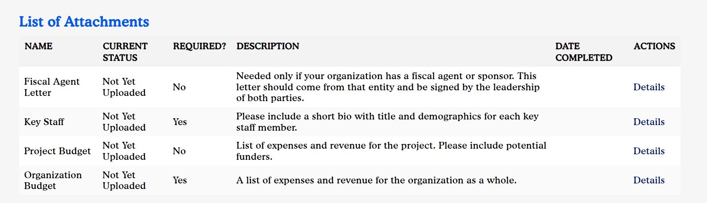

ADDITIONAL INFORMATION
- Funding will be awarded to schools/districts and nonprofits that organize students, parents, and community members, engage in education policy advocacy to advance equity and eliminate disparities, and help educators collaborate to build their understanding of race, equity and culture and create positive school climates.
- The Foundation plans to award $1.2 million to $1.4 million to 25 to 30 organizations. Grant awards will range from $10,000 to $75,000 with an average grant size between
$25,000 and $40,000. The grant period is September 1, 2023, to June 15, 2024.
- The Foundation will prioritize proposals that impact Minneapolis; however, we will also consider organizations working in communities in the inner ring suburbs (Brooklyn Park, Brooklyn Center, Robbinsdale, St. Louis Park, etc.).
- All applicants will be notified of their application status (declined or funded) via email by August 21, 2022.
- Please contact Patrice Relerford at prelerford@mplsfoundation.org with questions related to your eligibility or the content of your proposal.
- If you experience technical difficulties with the online application, please contact Grant Administration at grantsupport@mplsfoundation.org or 612-672-8665.
- We strongly encourage each individual grant writer to have their own account, as multiple accounts can be associated with one organization. Please do not share accounts. This helps with the notification process and ensures you will receive timely notice of your grant approval/denial.
- The online application will close at 1 p.m. on June 27th. We do not accept late applications or applications submitted via email.
- Please allow 1 to 2 business days for responses from our staff. Also, we strongly encourage applicants to apply prior to the deadline.
- Grantees will be asked to submit a brief narrative report and itemized budget at the conclusion of the grant period. Please note our grant reports emphasize learning and reflection with our grantee partners, not judgement.

